Project Topic: ResuMatch

Problem Statement
Job seekers often struggle to create resumes that are optimized for Applicant Tracking Systems (ATS) and properly aligned with specific job descriptions. As a result, qualified candidates may be overlooked during the initial screening process.
There is a need for an accessible and intelligent platform that can analyze resumes, compare them with job descriptions, and provide meaningful feedback to help candidates improve their chances of being shortlisted.

Project Goal
The goal of ResuMatch is to develop a smart, cloud-based resume analysis platform that evaluates resumes and provides an ATS-based matching score. The system helps job seekers understand how well their resume aligns with a particular job description and provides suggestions for improvement.

Introduction
ResuMatch is a smart resume analysis platform designed to help job seekers evaluate and improve their resumes for specific job roles.
The application allows users to upload their resumes and optionally provide a job description. The system processes the resume using AWS cloud services, extracts relevant information, and analyzes the content to generate an ATS-based score, strengths, improvement suggestions, and job recommendations.
The platform is built using a serverless cloud architecture, making it scalable, cost-effective, and easy to maintain.

Features of ResuMatch

1. Cloud-Based Resume Storage
- User-uploaded resumes are stored in Amazon S3.
- Enables secure and scalable cloud storage.
- Allows resumes to be retrieved for preview, download, and analysis.

2. Resume Analysis
The application analyzes uploaded resumes and provides:
- ATS-based matching score
- Resume strengths
- Improvement suggestions
- Tone and language analysis
- Job recommendations
Users can optionally provide a job description to receive a more targeted analysis.

3. Resume History
Users can view their previously uploaded resumes.
The history section provides information such as:
- Resume name
- Upload date
- ATS score
- Resume preview

4. Resume Preview, Download, and Delete
The application provides resume management functionality, allowing users to:
- Preview uploaded resumes
- View analysis reports
- Download resumes
- Delete resumes and associated reports

5. Serverless Backend Architecture
The backend uses AWS Lambda to process application requests without requiring traditional server management.
Lambda functions handle tasks such as:
- Generating presigned S3 URLs
- Uploading resumes
- Processing resume analysis requests
- Fetching resume history
- Deleting resumes and reports

6. Secure API Communication
Amazon API Gateway is used to connect the frontend application with AWS Lambda functions.
It manages API requests for:
- User operations
- Resume uploads
- Resume analysis
- Resume history
- Resume deletion

7. AI-Based Resume Processing
The system uses AWS services to process resume content.
Amazon Textract is used to extract text from uploaded resume documents.
Amazon Comprehend is used to analyze the extracted text and identify relevant information that can assist with resume and job description analysis.

Technology Stack

Frontend

1. HTML5
Used to structure the web pages and application content.

2. CSS3
Used to style the application and create a responsive user interface.

3. JavaScript
Used to add interactivity and communicate with backend APIs.

4. Tailwind CSS
Used to create responsive and modern user interface components.

Backend and Cloud Services

1. AWS Lambda
Used to run backend functions without managing servers.

2. Amazon S3
Used to store uploaded resumes and generated analysis reports.

3. Amazon API Gateway
Used to expose backend APIs and route requests between the frontend and AWS Lambda.

4. Amazon DynamoDB
Used to store and manage application user data.

5. Amazon Textract
Used to extract text from uploaded resume documents.

6. Amazon Comprehend
Used to analyze extracted resume text and identify relevant information for resume analysis.

7. AWS IAM
Used to manage roles and permissions for AWS services and Lambda functions.

8. Amazon CloudWatch
Used for monitoring, logging, and debugging backend Lambda functions and application errors.

9. Amazon CloudFront
Used to deliver the frontend application and static content with improved performance and lower latency.

Project Workflow

Step 1: User Registration and Login
The user creates an account or logs into the ResuMatch application through the frontend interface.
User information is managed through the backend and stored in the application's user database.

Step 2: Resume Upload
The user selects and uploads a resume through the ResuMatch user interface.
A presigned URL is generated by the backend, allowing the resume to be securely uploaded to Amazon S3.

Step 3: Job Description Input
The user can optionally provide a job description.
The job description is used to compare the resume with the requirements of a specific job role.

Step 4: Resume Processing and Analysis
After the resume is uploaded:
- The backend receives the resume analysis request.
- The resume is retrieved from Amazon S3.
- Amazon Textract extracts text from the resume.
- The extracted information is analyzed.
- The resume is compared with the provided job description.
- An ATS-based score and analysis results are generated.

Step 5: Display Analysis Results
The user is presented with the resume analysis results, which may include:
- ATS score
- Strengths and remarks
- Improvement suggestions
- Tone and language analysis
- Job recommendations
The analysis report can also be stored in Amazon S3 for future access.

Step 6: Resume History Management
Users can access their previously uploaded resumes through the Resume History section.
Users can:
- View uploaded resumes
- Preview resumes
- Check ATS scores
- Download resumes
- Delete resumes
- Access previous analysis reports

Step 7: User Logout
Users can securely log out of the application when they have finished using the platform.

Architectural diagram:
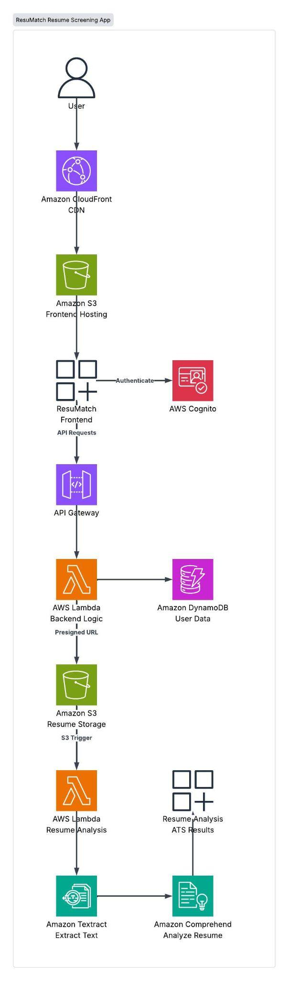

Architecture Diagram Description
The ResuMatch application follows a serverless and cloud-based architecture built using AWS services. The overall workflow is as follows:
- User:
The user accesses the ResuMatch application through a web browser.
- Amazon CloudFront (CDN):
Amazon CloudFront delivers the ResuMatch application efficiently to users and acts as a Content Delivery Network (CDN).
- Amazon S3 – Frontend Hosting:
The ResuMatch frontend, including HTML, CSS, and JavaScript files, is hosted in an Amazon S3 bucket and delivered through CloudFront.
- ResuMatch Frontend:
The frontend provides the user interface for authentication, resume uploads, job description input, and displaying the resume analysis results.
- AWS Cognito:
AWS Cognito is used to authenticate and manage users accessing the ResuMatch application.
- Amazon API Gateway:
API Gateway receives requests from the frontend and securely routes them to the backend services.
- AWS Lambda – Backend Logic:
AWS Lambda handles the backend operations, including generating presigned URLs, processing API requests, and managing communication between AWS services.
- Amazon DynamoDB – User Data:
DynamoDB stores user-related information and supports the application's user data management.
- Amazon S3 – Resume Storage:
Uploaded resumes are securely stored in an Amazon S3 bucket using presigned URLs.
- AWS Lambda – Resume Analysis:
When a resume is uploaded, the S3 upload event triggers the Resume Analysis Lambda function.
- Amazon Textract:
Amazon Textract extracts text and relevant information from the uploaded resume.
- Amazon Comprehend:
Amazon Comprehend analyzes the extracted resume text to identify relevant keywords and information required for resume analysis.
- Resume Analysis / ATS Results:
The processed information is used to generate the resume analysis and ATS results, which are then displayed to the user through the ResuMatch frontend.

Overall Flow
User → CloudFront → S3 Frontend Hosting → ResuMatch Frontend → API Gateway → Lambda → S3 / DynamoDB
For resume analysis:
Resume Upload → S3 Resume Storage → Resume Analysis Lambda → Amazon Textract → Amazon Comprehend → Resume Analysis / ATS Results
ResuMatch screenshots:
Signup:
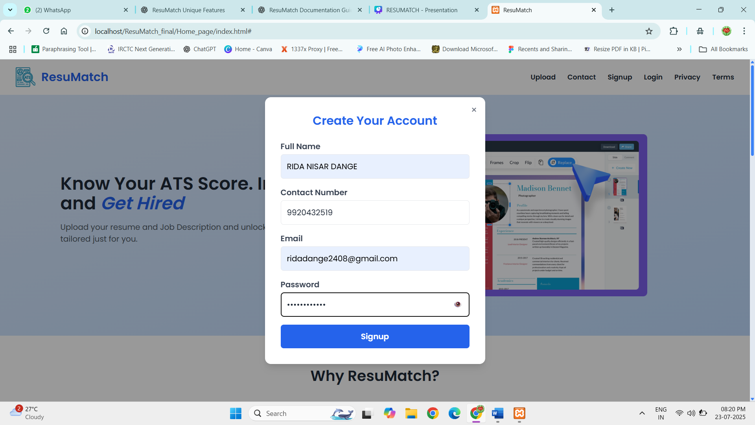

Home page:
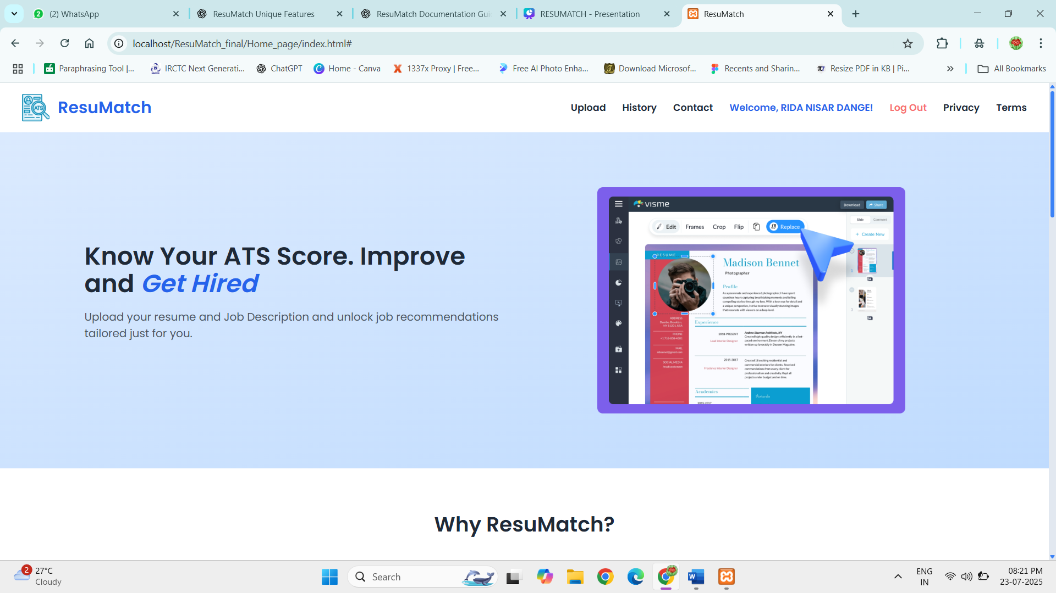
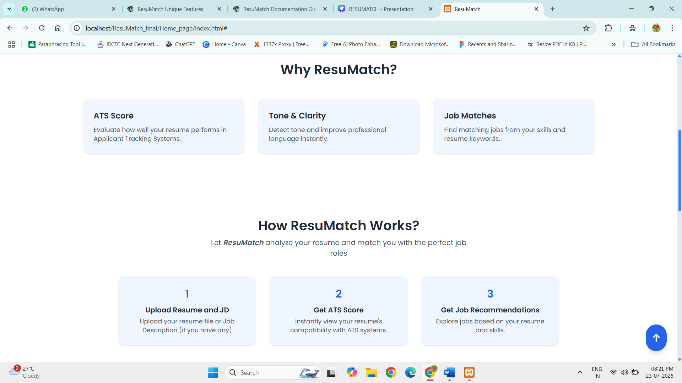

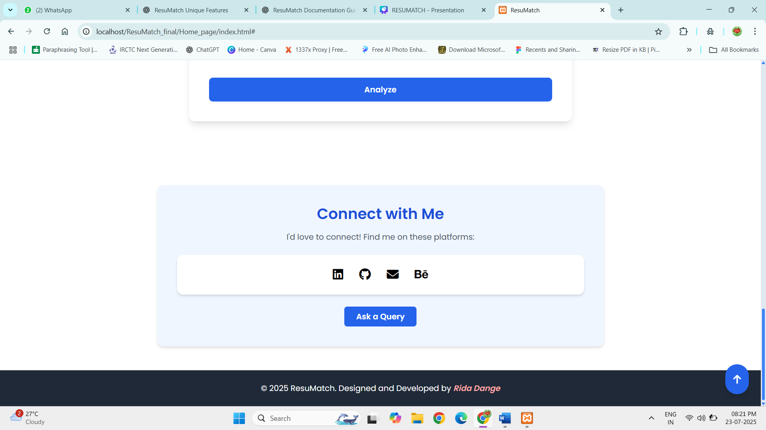

Resume analyze without JD:
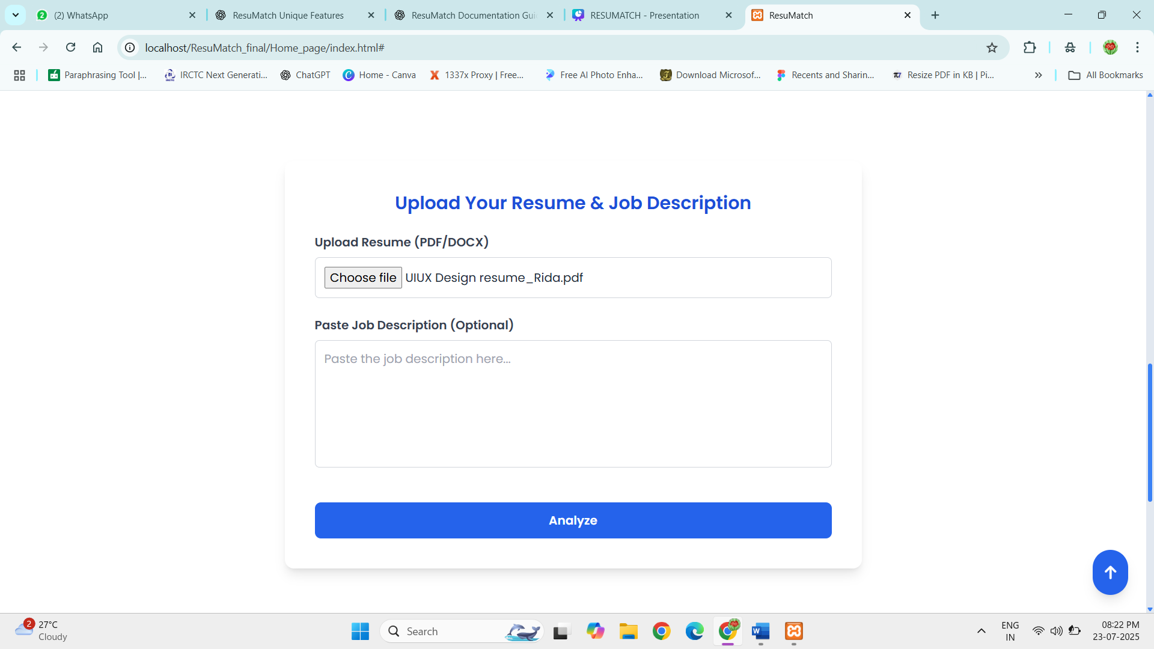

Resume analyze with JD:
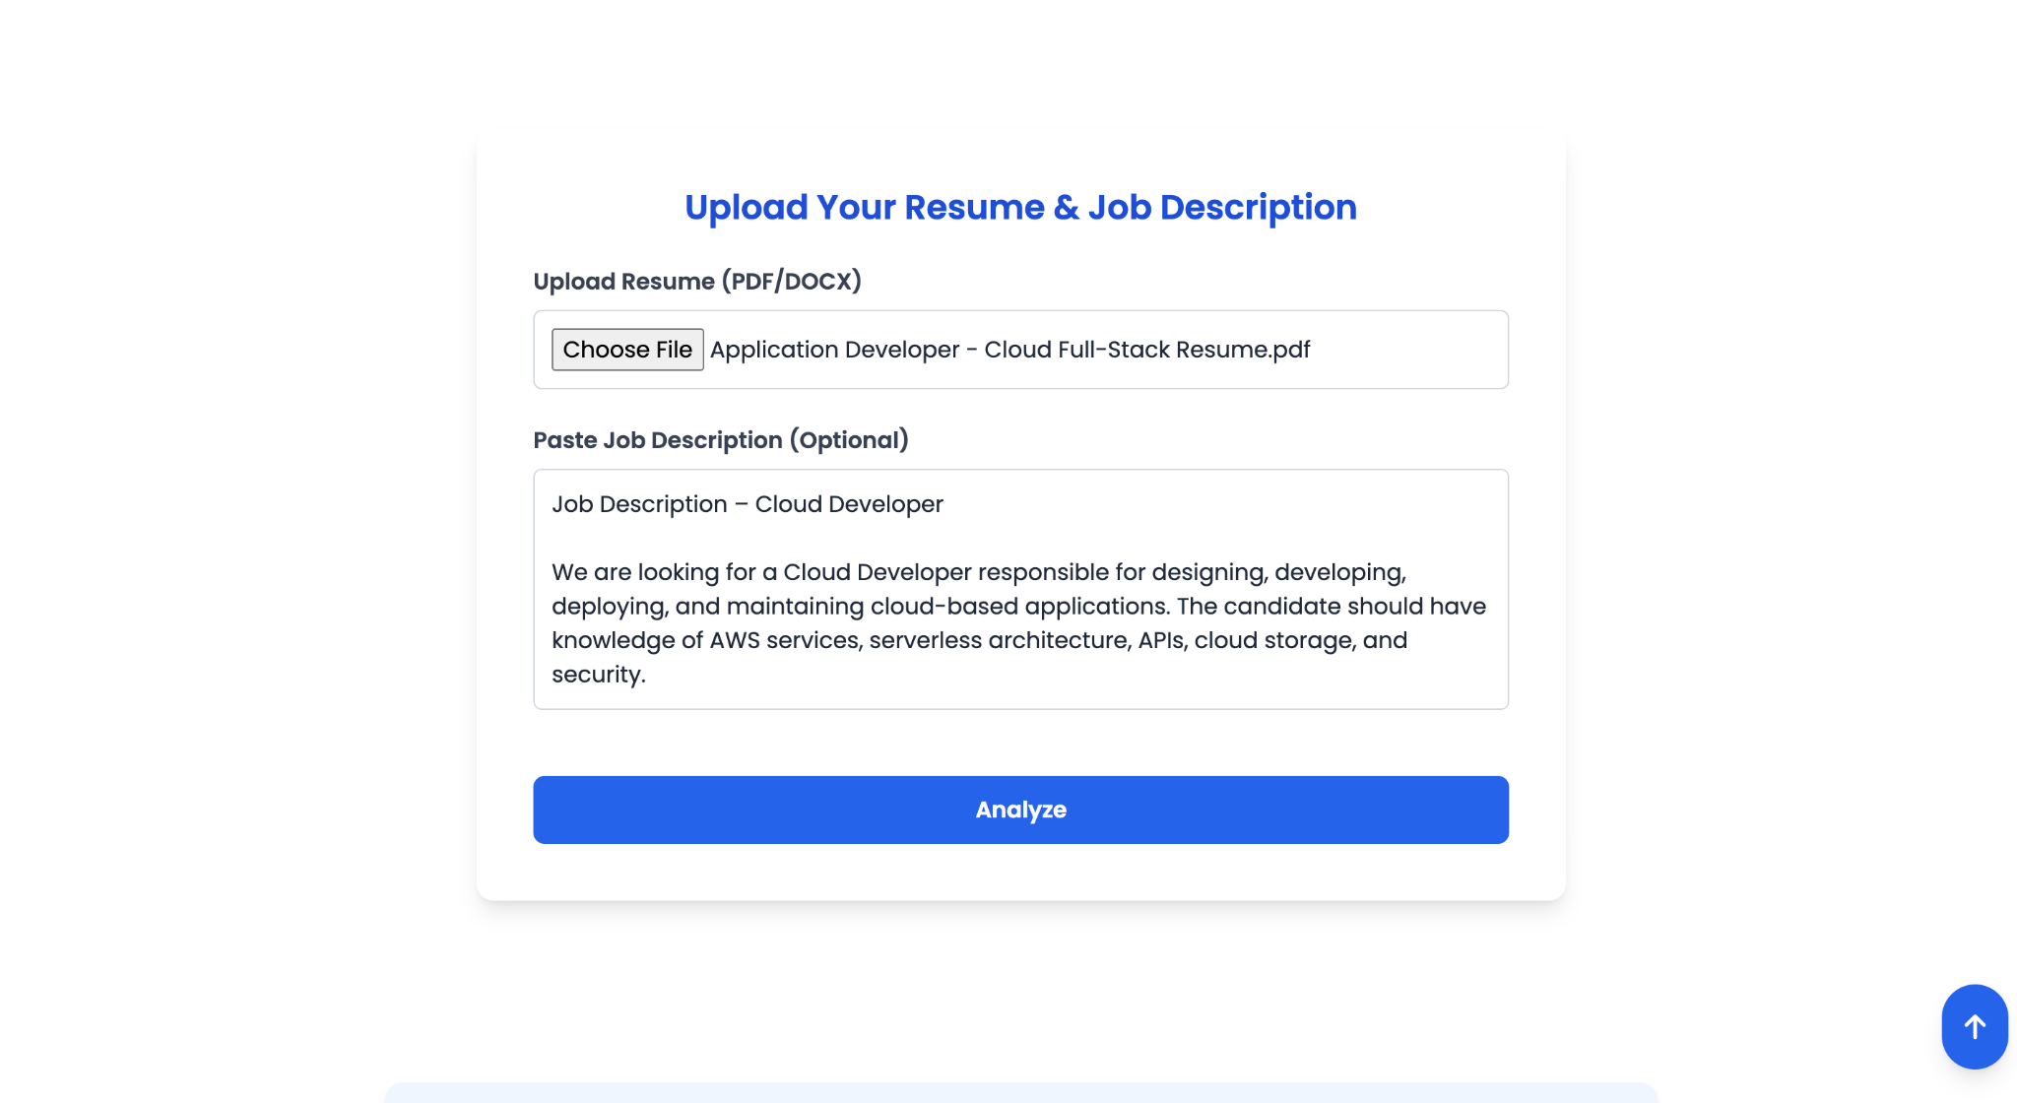

Analysis page:
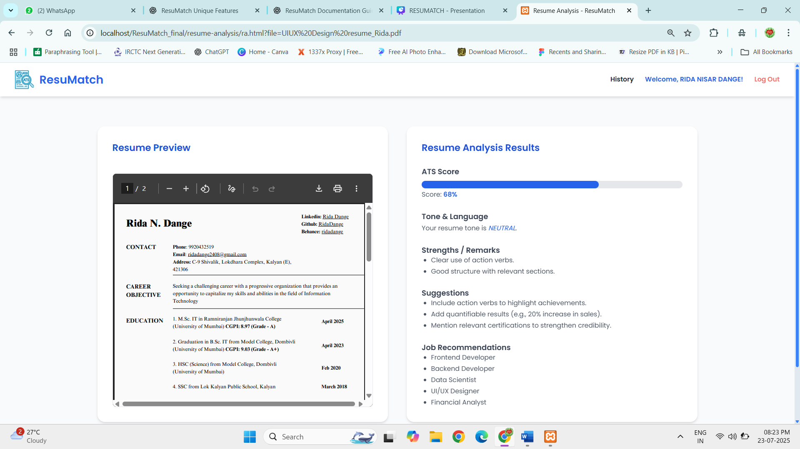

History page:
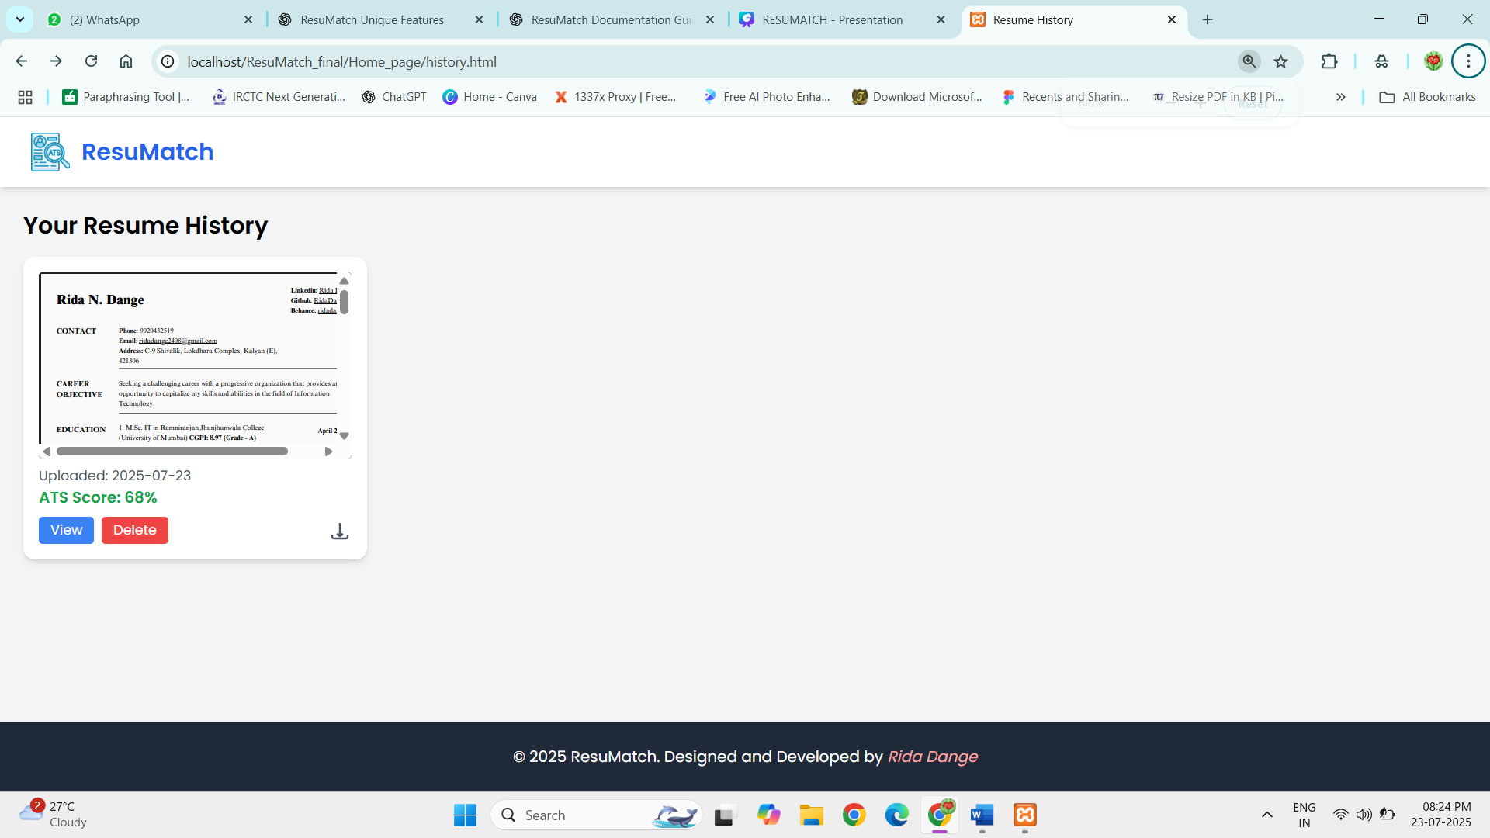

AWS Services and Components Used in ResuMatch

Amazon Cognito
Amazon Cognito is used to provide secure user authentication and authorization for the ResuMatch application.
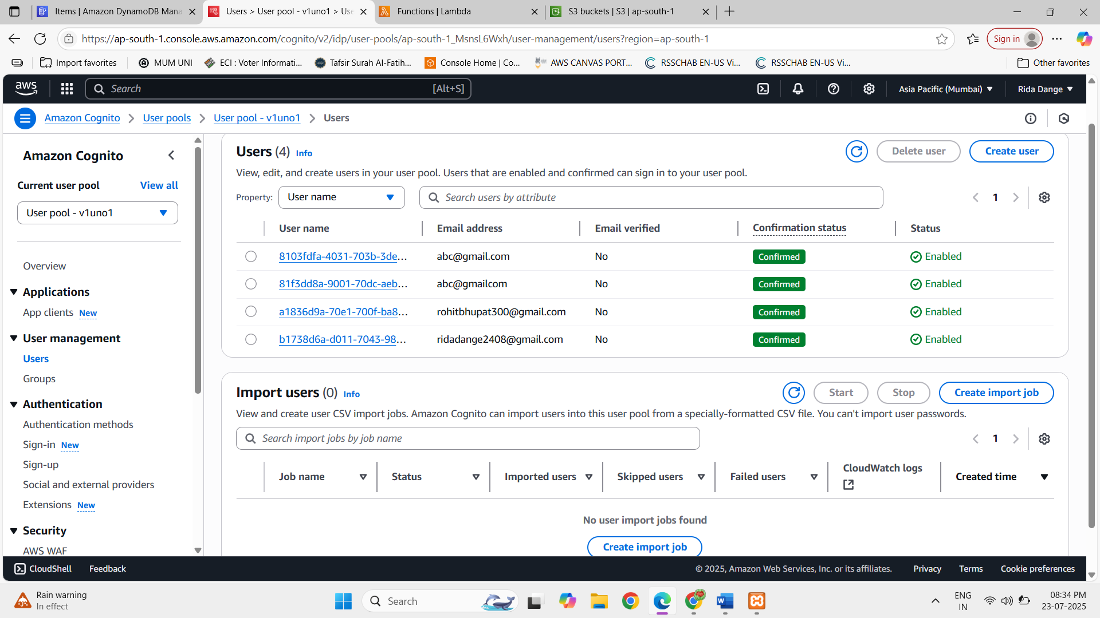

AWS Lambda Functions
AWS Lambda is used to run the backend logic of the ResuMatch application. Different Lambda functions are created to handle different operations.
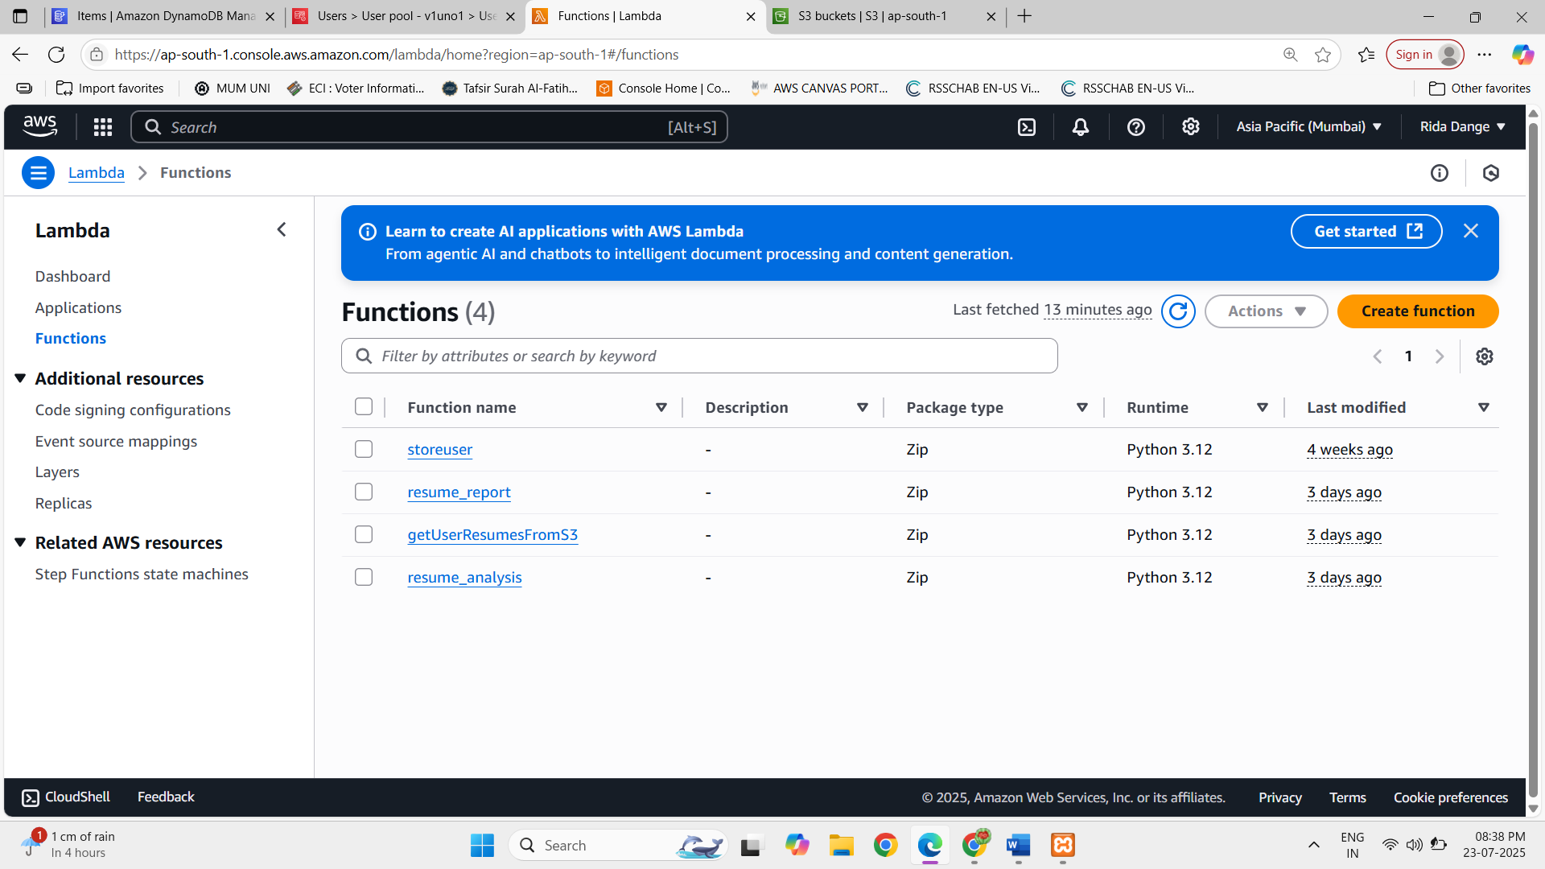

1. StoreUser Function
The StoreUser Lambda function contains the backend logic for storing user information. It processes user registration data received from the frontend and stores the relevant user details in Amazon DynamoDB.
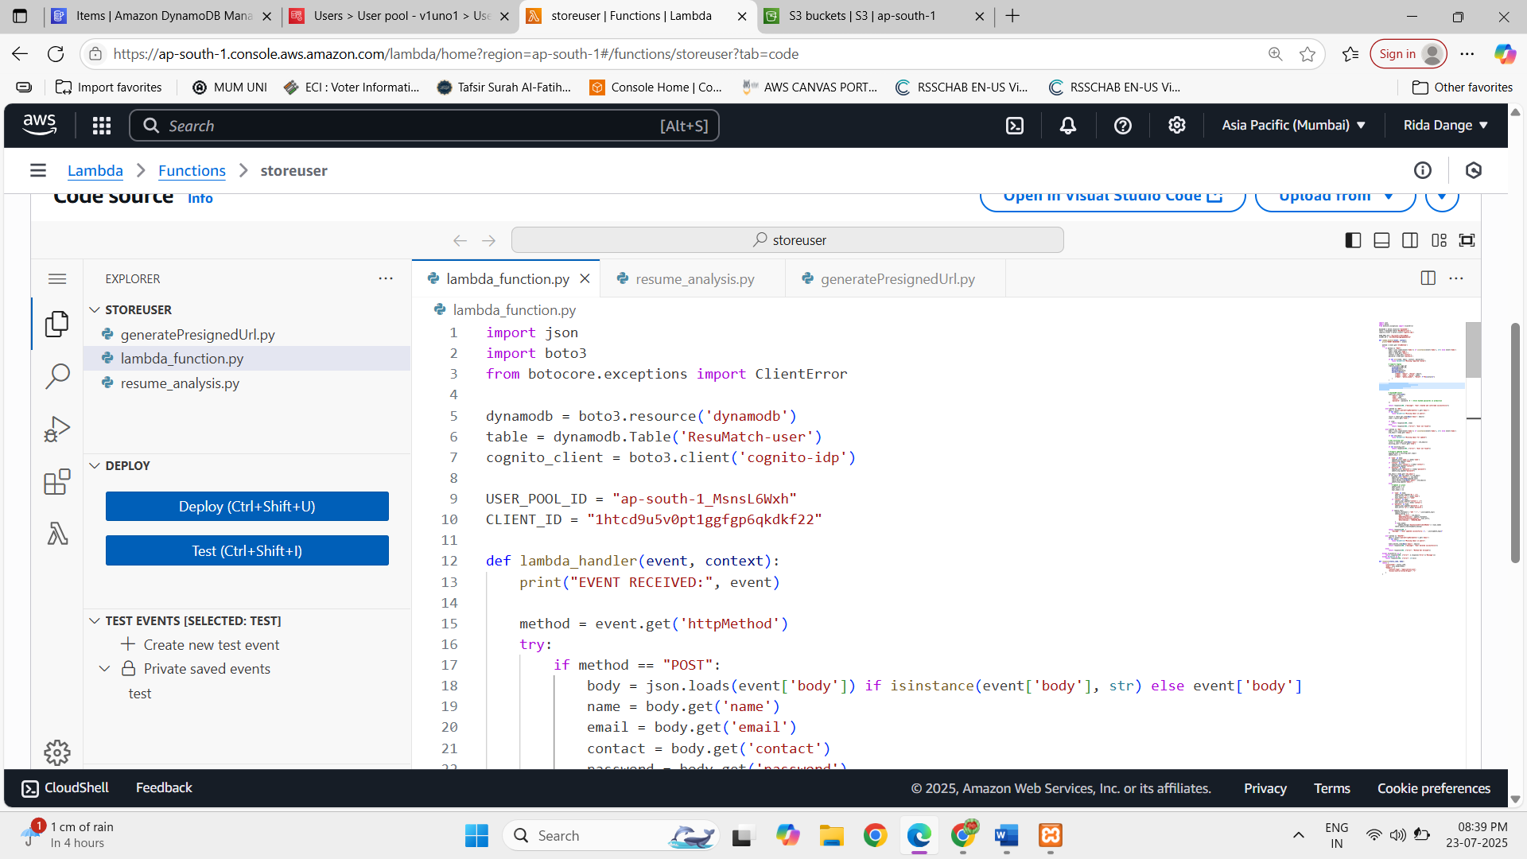

2. Resume Report Function
The Resume Report Lambda function handles the generation and storage of resume analysis reports. After a resume is analyzed, the generated report, including the ATS score and other analysis results, is processed and stored for future access.
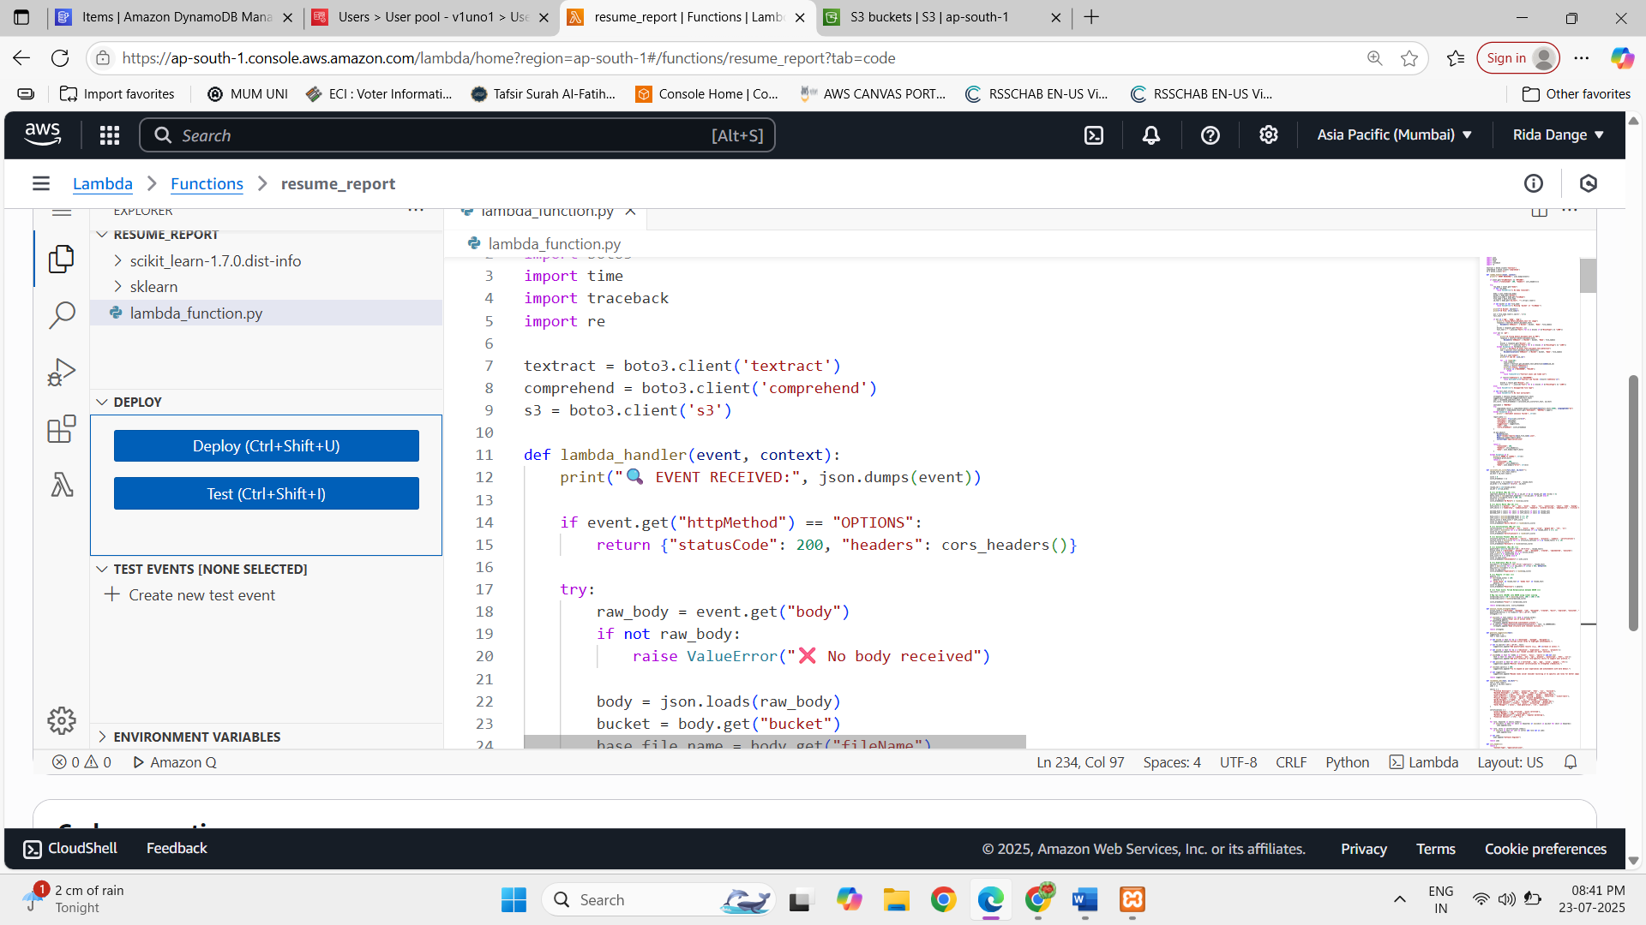

3. getUserResumesFromS3 Function
The getUserResumesFromS3 Lambda function is responsible for retrieving previously uploaded resumes from the Amazon S3 bucket.
This function fetches the available resume files from the backend and sends the information to the frontend, where the resumes are displayed on the Resume History page. It also handles resume deletion requests from the application.
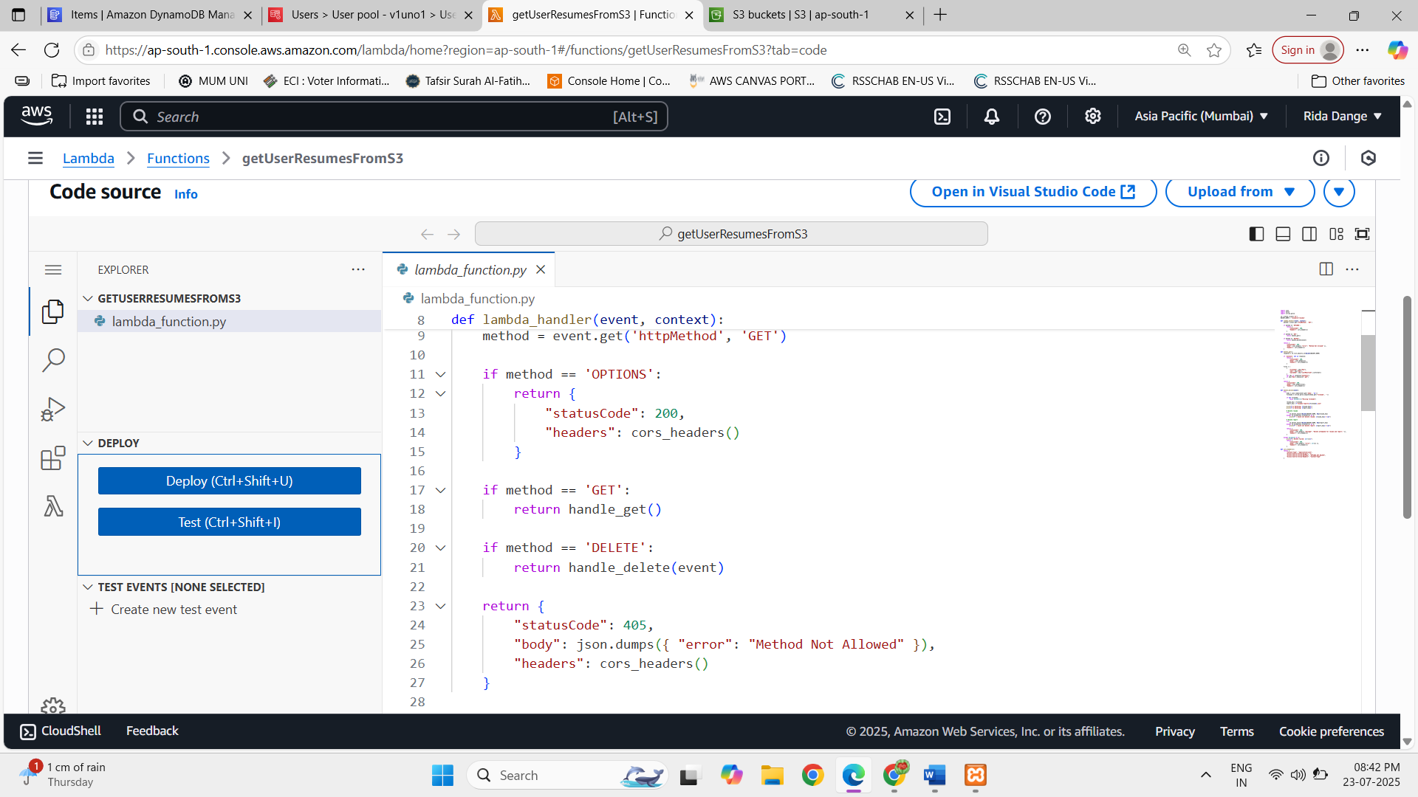

4. Resume Analysis Function
The Resume Analysis Lambda function contains the main backend logic for analyzing uploaded resumes.
The function processes the resume stored in Amazon S3, extracts and analyzes the resume content, compares it with the provided job description (if available), and generates results such as:
- ATS score
- Resume strengths
- Improvement suggestions
- Tone and language analysis
- Job recommendations
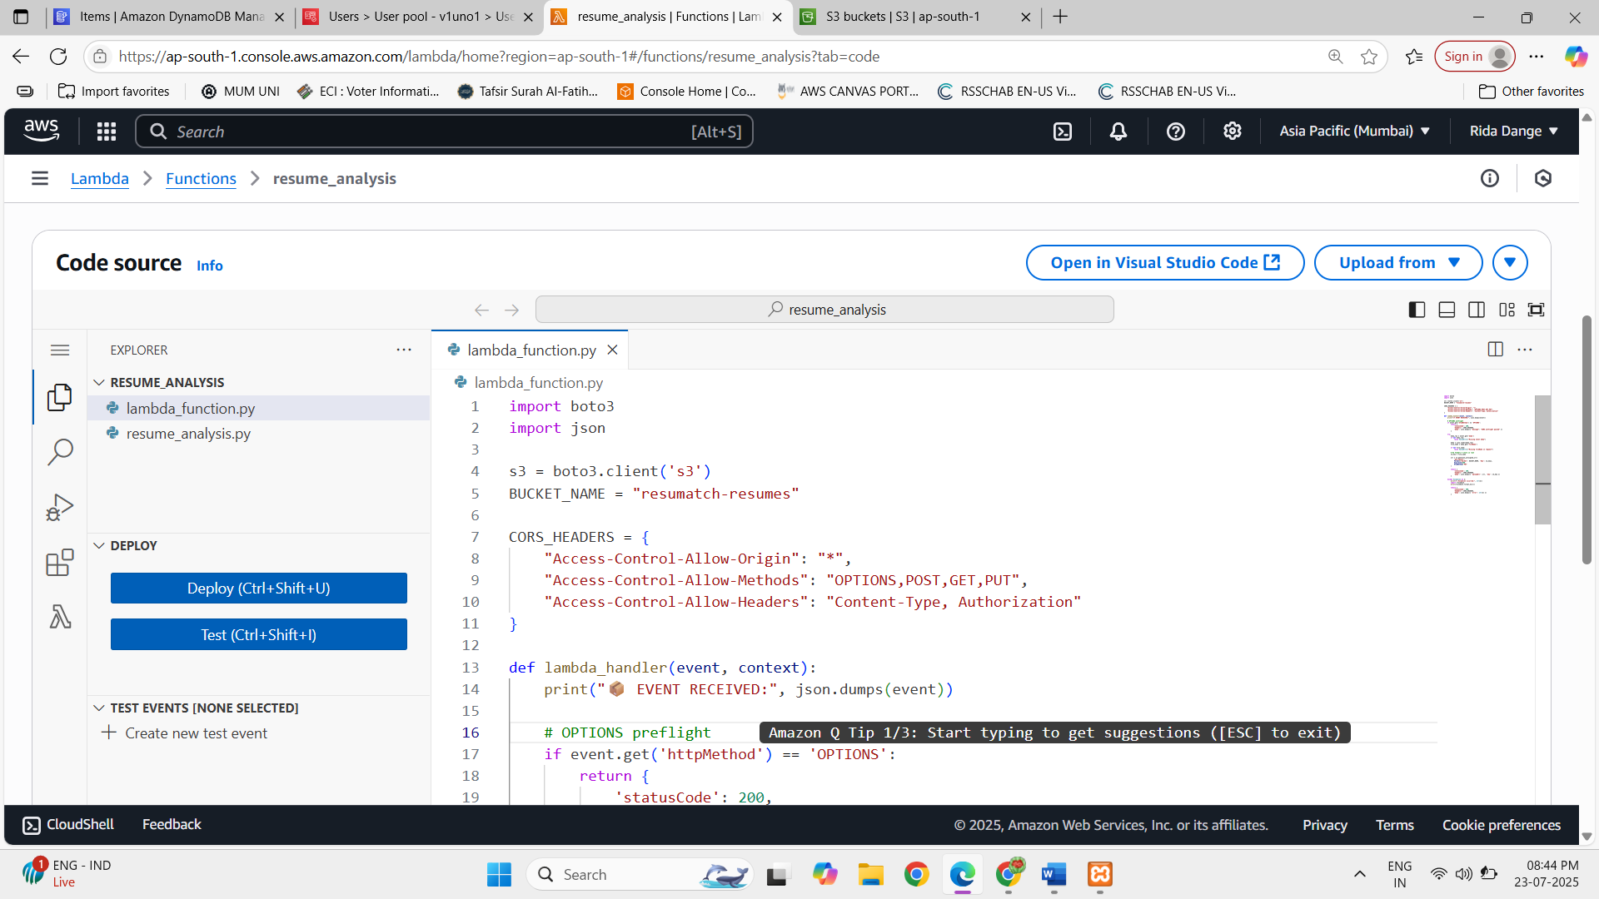

Amazon API Gateway
Amazon API Gateway acts as a bridge between the ResuMatch frontend and backend. It receives requests from the frontend and routes them to the appropriate AWS Lambda functions.
It is used for:
- User registration and login
- Resume upload and analysis
- Fetching resume history
- Deleting resumes
Flow: Frontend → API Gateway → AWS Lambda → AWS Services
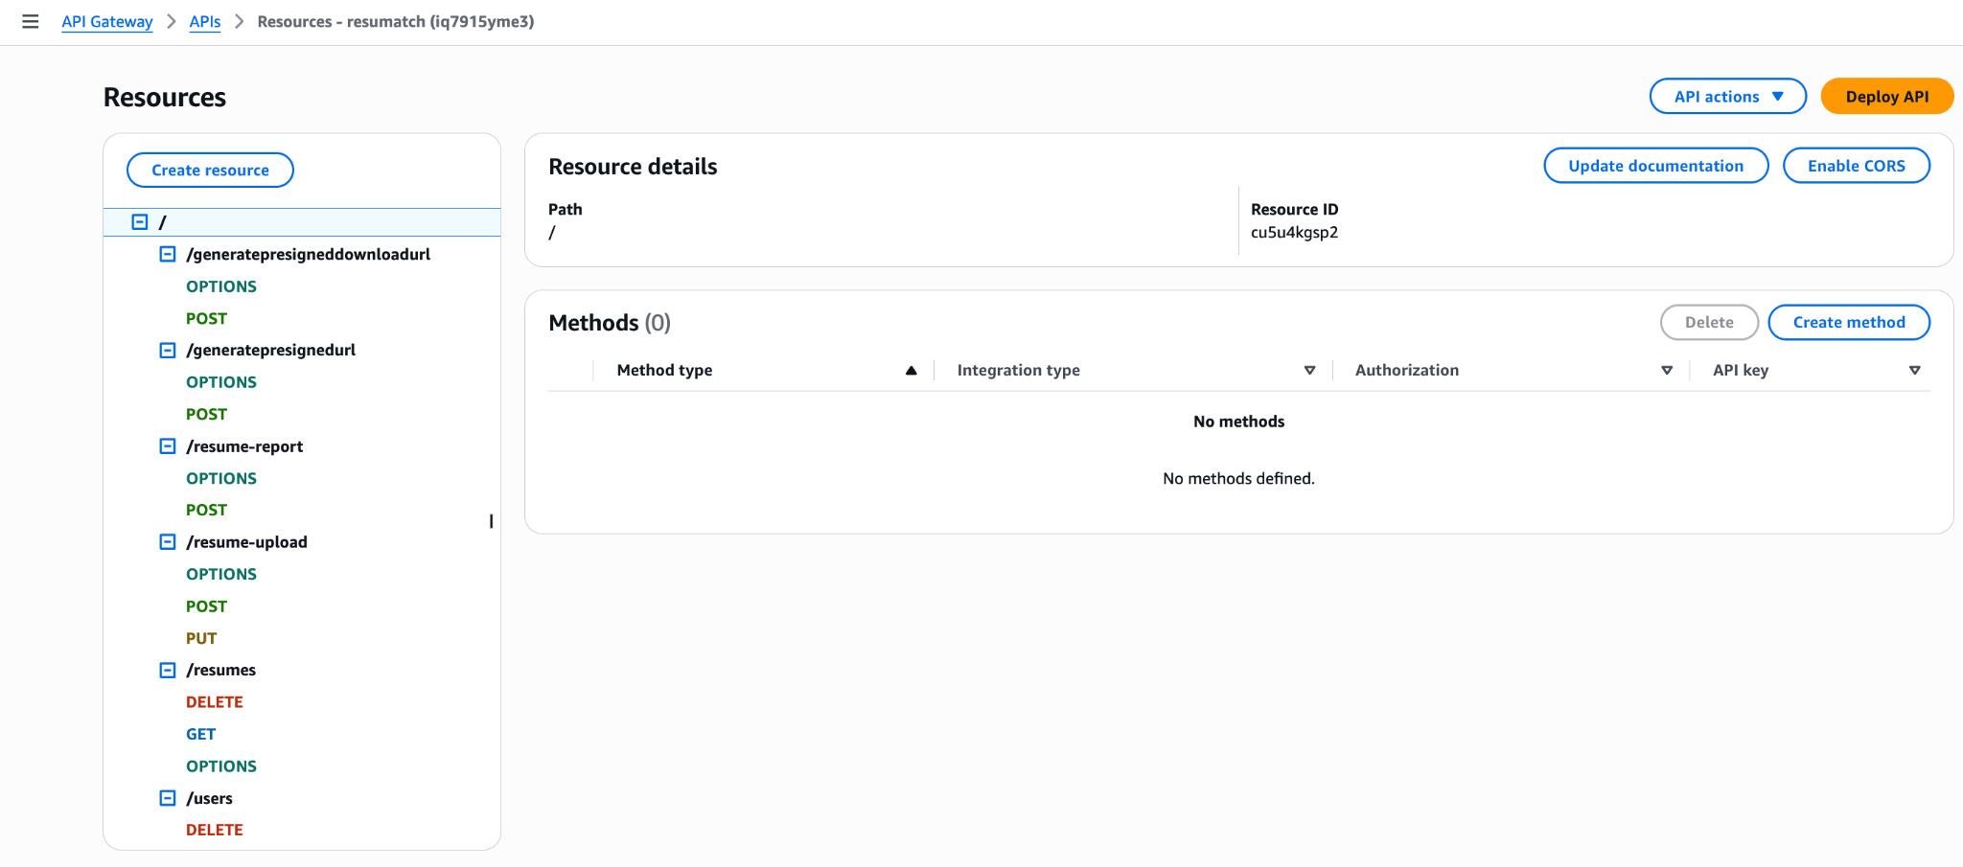

Amazon DynamoDB
Amazon DynamoDB is used to store and manage user-related data for the ResuMatch application. This includes user information such as registration and login details.
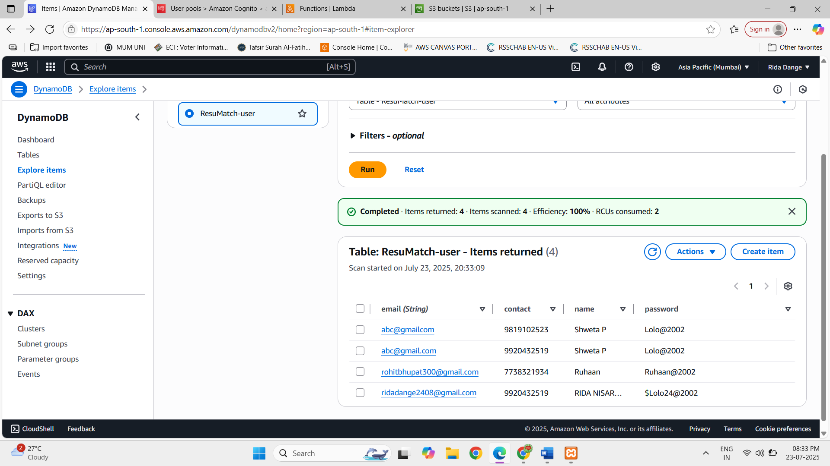

Amazon S3 Bucket
Amazon S3 is used as the cloud storage service for the ResuMatch application.
The S3 bucket stores:
- Resumes uploaded by users from the frontend
- Resume analysis reports
- Frontend source code and static website files
S3 provides scalable and reliable cloud storage for the application.

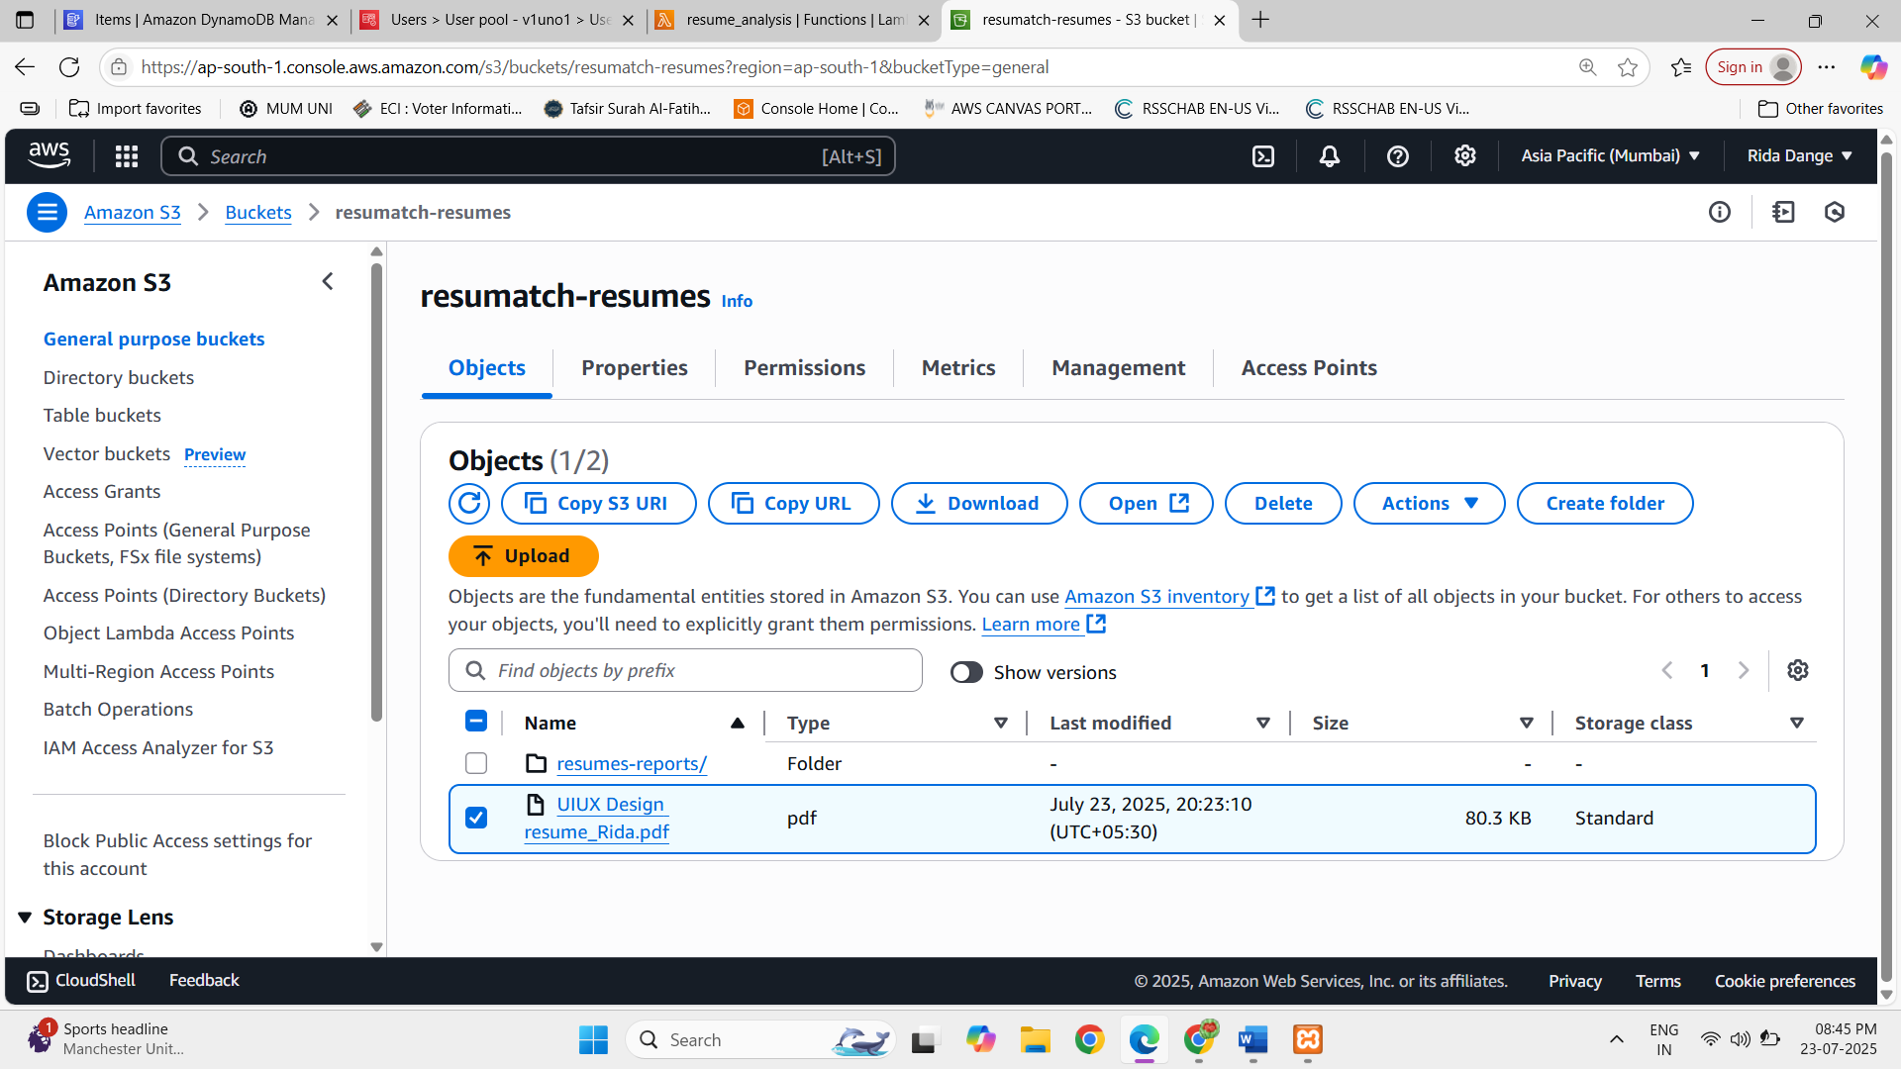
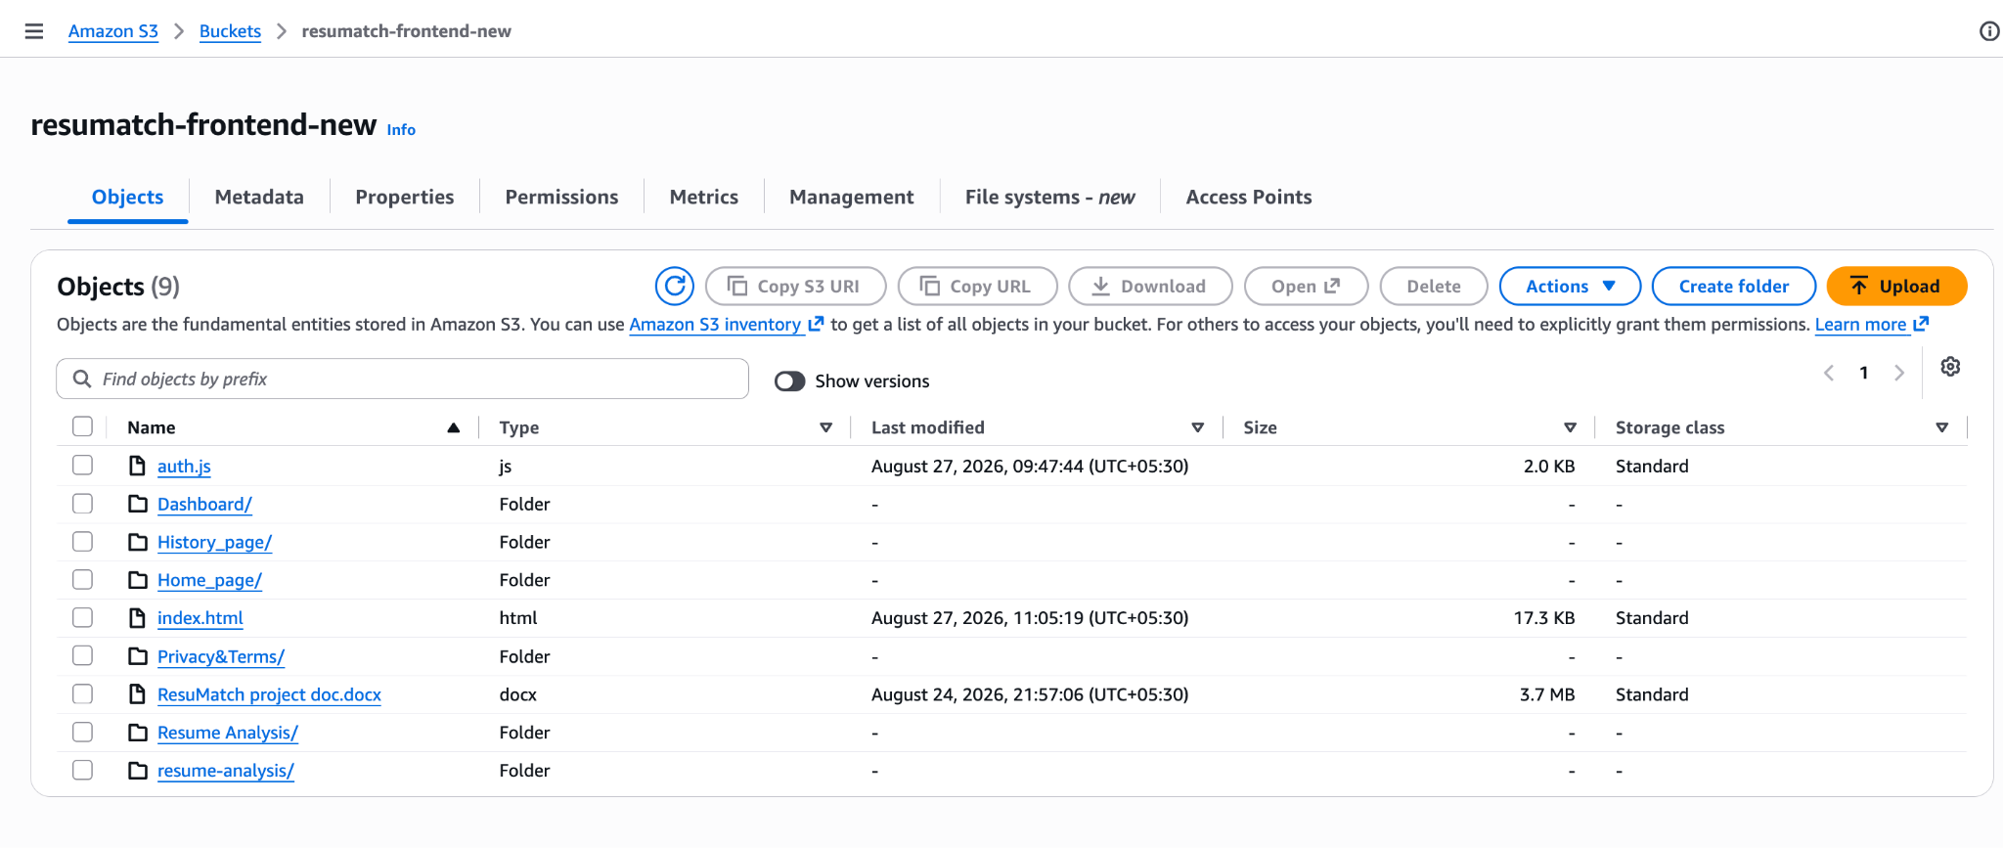

Amazon CloudFront
Amazon CloudFront is used as a Content Delivery Network (CDN) to deliver the ResuMatch frontend application to users.
The frontend source code is stored in the Amazon S3 bucket, and CloudFront distributes the website content efficiently to users.
CloudFront helps improve:
- Website loading speed
- Performance
- Content delivery
- Scalability
The overall frontend delivery flow is:
User → CloudFront → Amazon S3
